Experiment 17:
Source code:
#include <reg51.h>
unsigned char data_received;
void serial_ISR(void) interrupt 4
{
if (RI == 1)
{
data_received = SBUF; // Receive data
RI = 0; // Clear receive interrupt
SBUF = data_received; // Echo the received data
}
if (TI == 1)
{
TI = 0; // Clear transmit interrupt
}
}
void main()
{
TMOD = 0x20; // Timer 1, Mode 2
TH1 = 0xFD; // Baud rate setting
SCON = 0x50; // Serial Mode 1, receiver enabled
TR1 = 1; // Start Timer 1
ES = 1; // Enable serial interrupt
EA = 1; // Enable global interrupt
while(1);
}

Output:
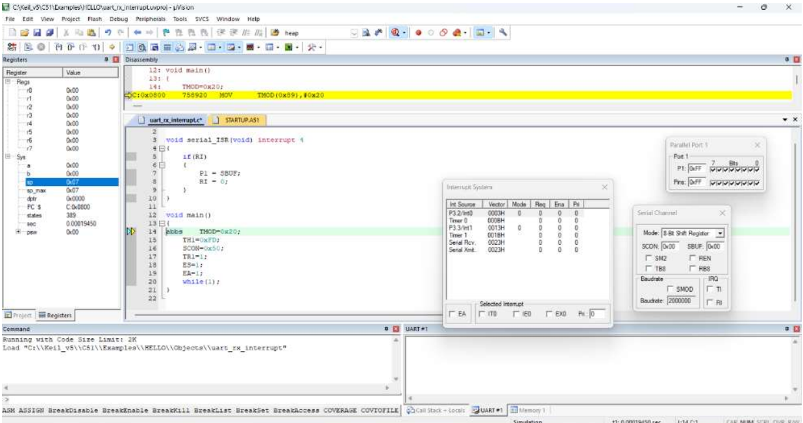
Before interruption:

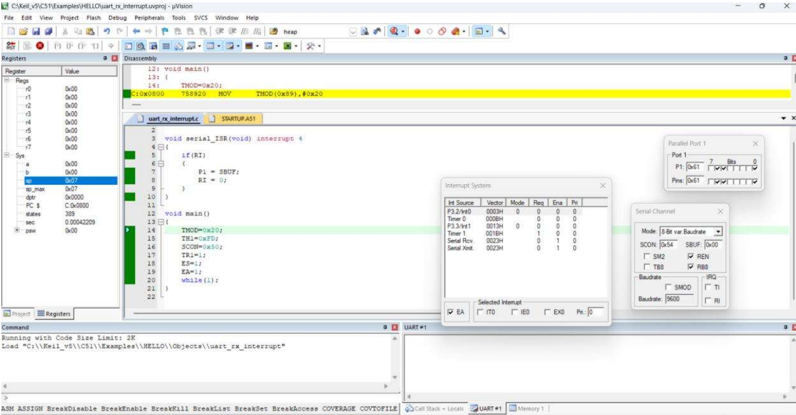
After interruption:

